Step by Step Domain Controller in Windows Server 2019 Preview Ed

Table of Contents

LAB Setup of Server 2019 3

Software Requirement 3

Hardware Requirement 3

Server 2019 Server Properties 4

Server Manager Properties 4

Deployment Configuration of Domain 9

Exploring Active Directory 13

DNS Configurations 14

Reverse Lookup Configuration 19

# LAB Setup of Server 2019

As Microsoft has release new Windows Server 2019 with more enhanced features and security related stuff. We have preview editions available to take a look and drive it look more in depth.

In today Lab we will see the installation of Windows Server 2019 Preview Edition as Domain Controller.

# Software Requirement

You can download preview edition of Server 2019 from Microsoft in ISO format.

# Hardware Requirement

In this lab environment, we have following VM specifications.

* 4 GB RAM
* 2 Core vCPU
* 100 GB HDD
* 1 NIC Card with Static IP Address

You can enable internet access on this machines for windows updates.

Let’s start installation from Server Manager. We have already cover Server Name IP Address and other setting so basic setting will be cover in this article.

# Server 2019 Server Properties

Here you can have a look to the basic setting such as time zone, IE security settings, firewall and remote desktop with server name etc.

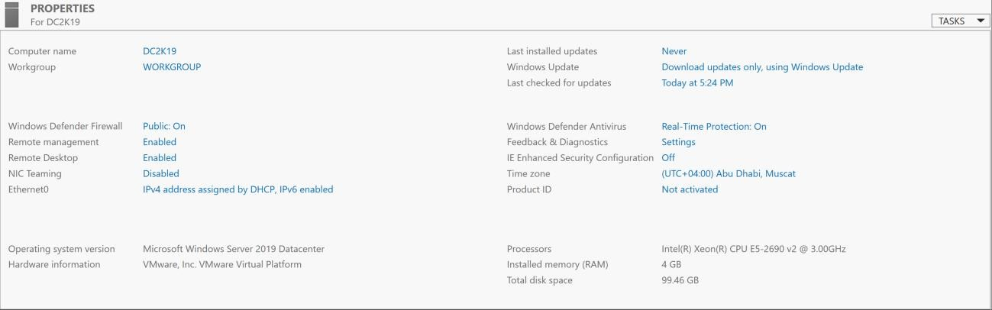

# Server Manager Properties

Click on Add roles and features

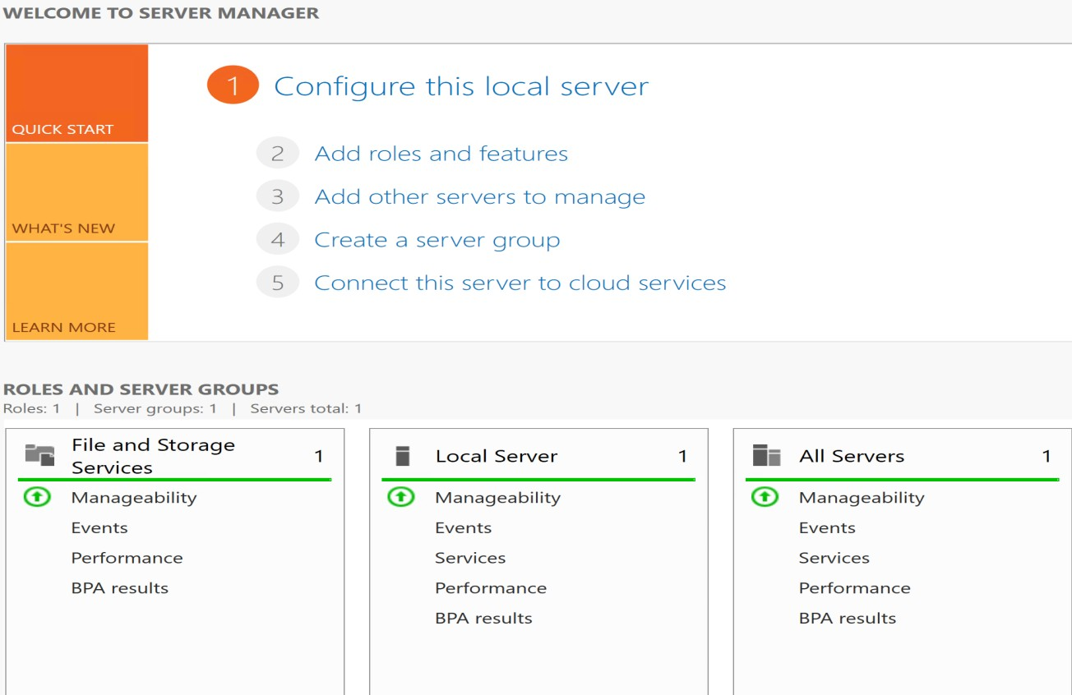

Click Next

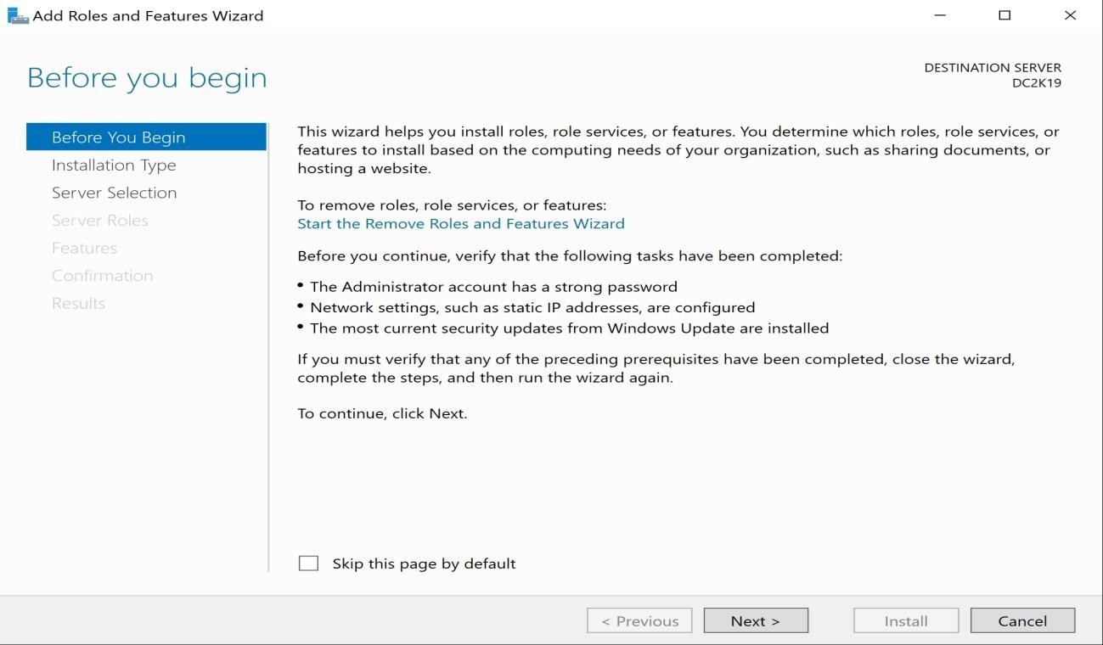

Click first option and Next

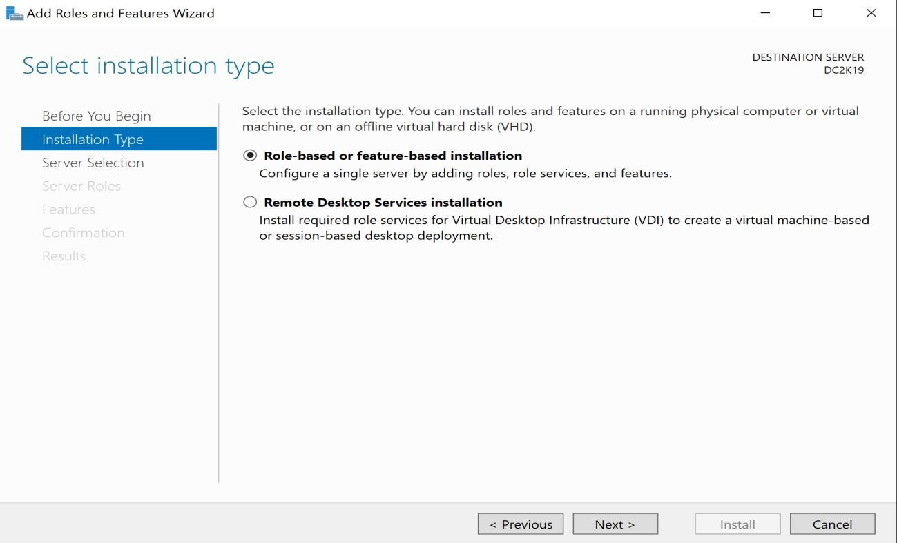

Click Next with first option

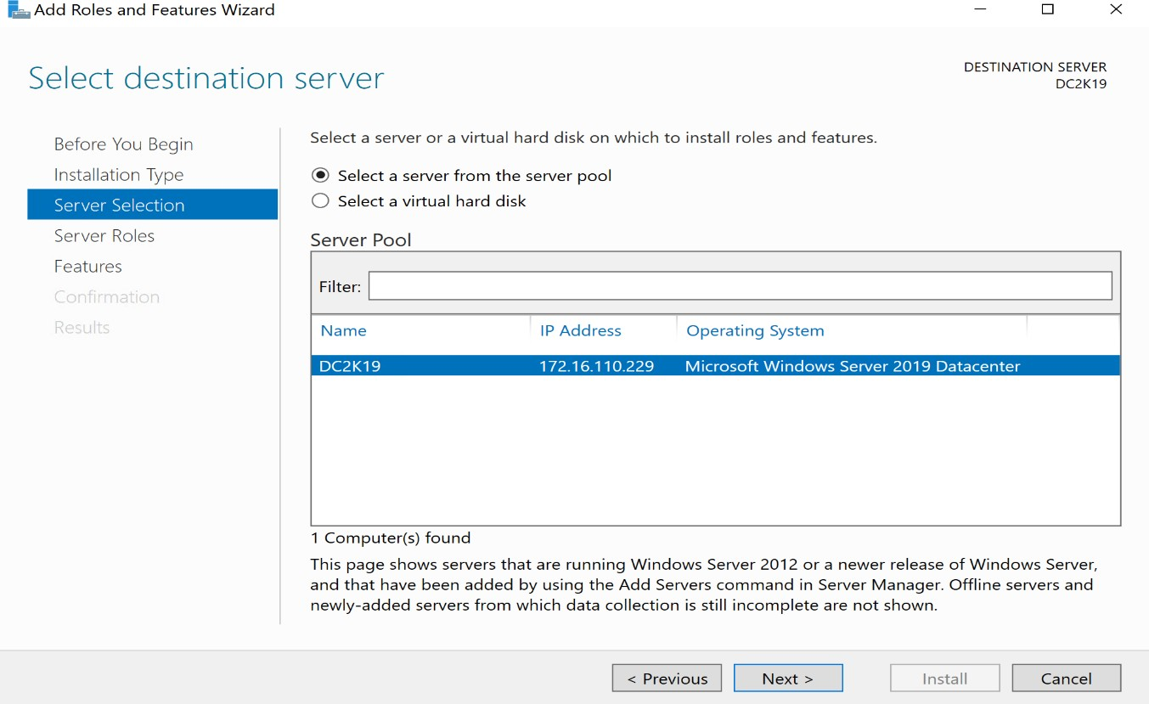

Select Active Directory Domain Services and add click features

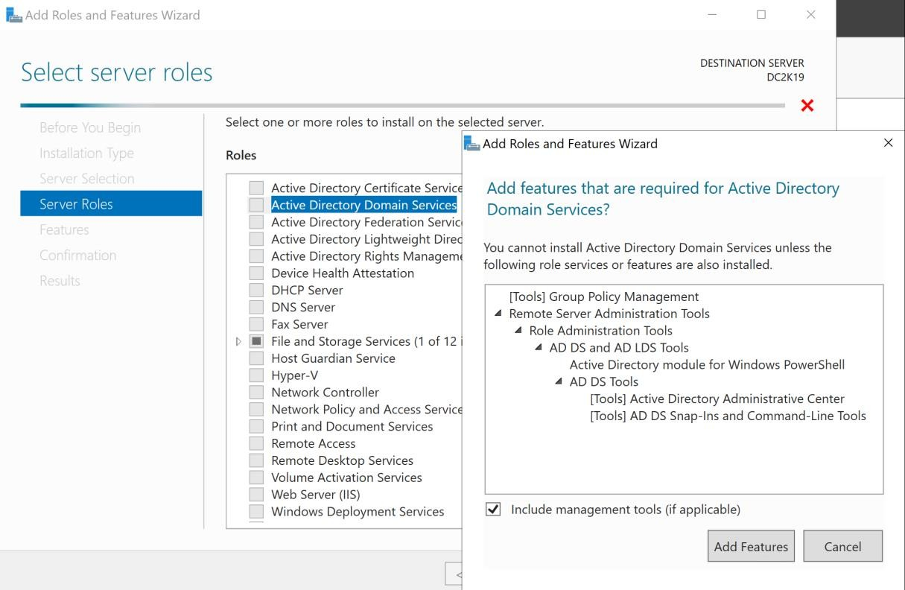

Keep default setting and click Next

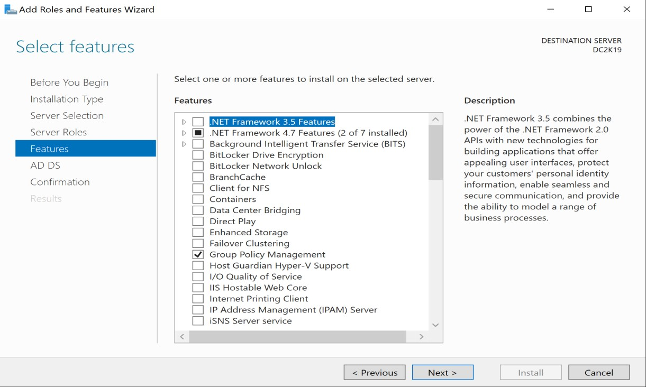

Click Next

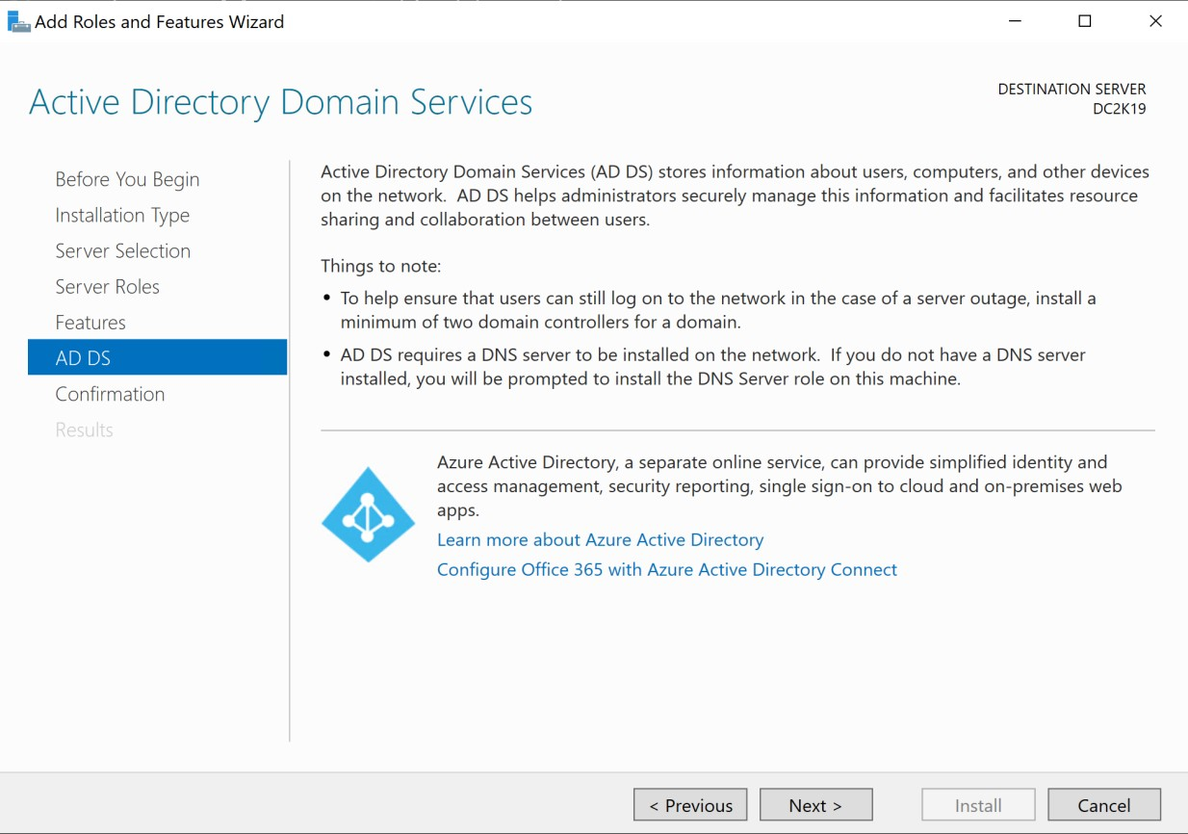

Click restart if you want otherwise you can click on Install option without restart

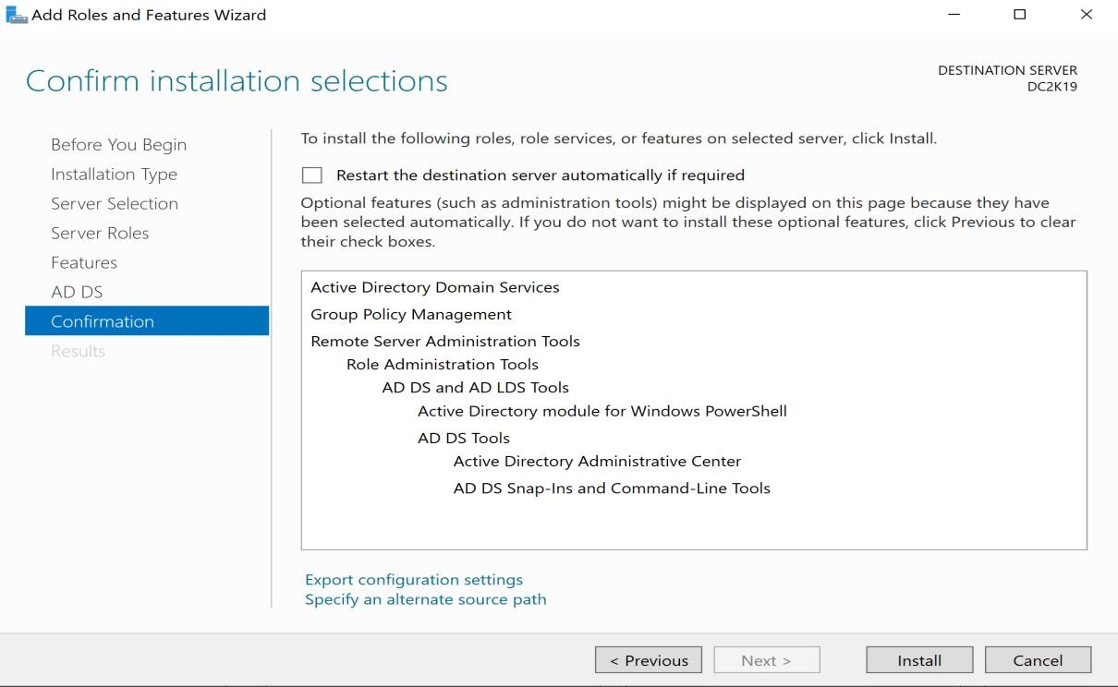

Click Promote this Server to a domain controller option

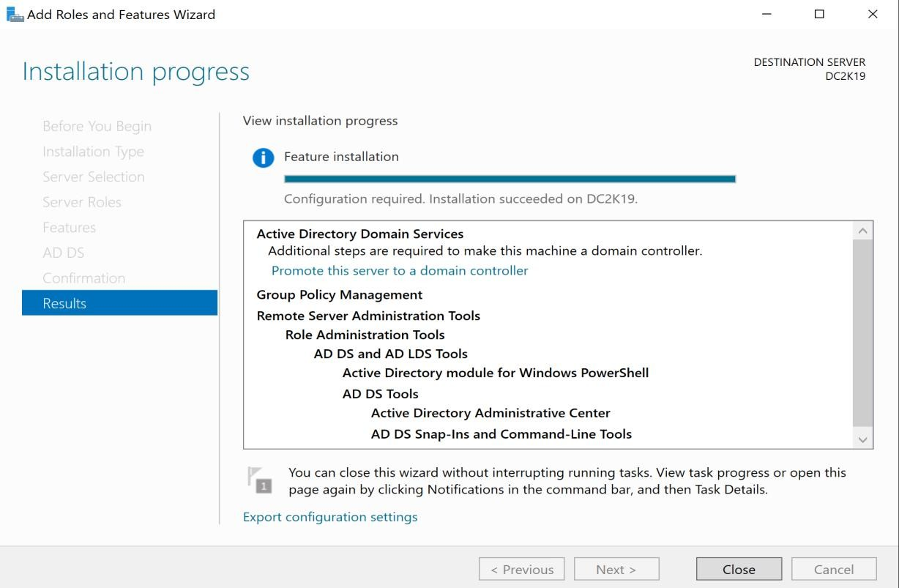

You can also close this wizard and start domain controller installation from Server Manager as previous in Windows Server 2016. Select third option and give a new domain name as desired.

# Deployment Configuration of Domain

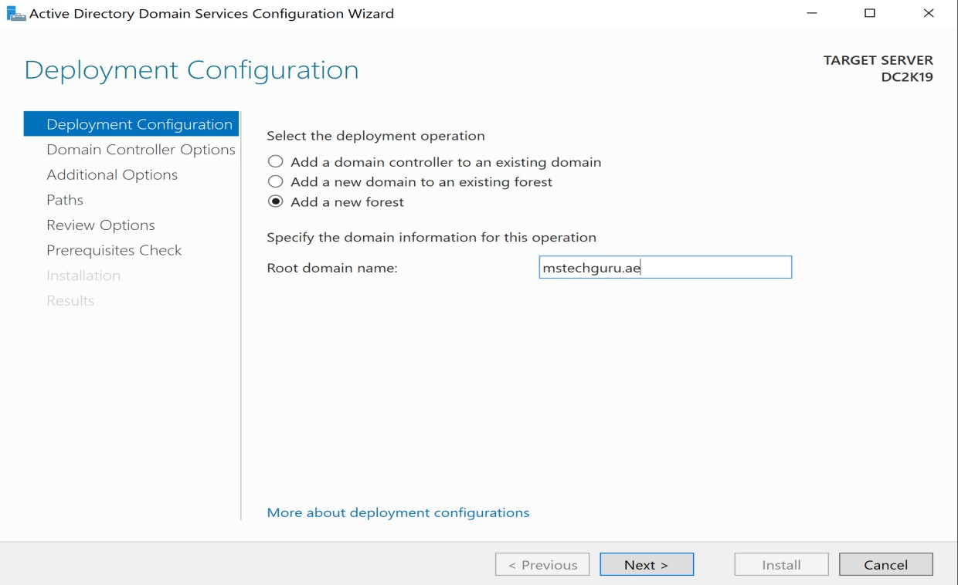

Keep functional level default as this is brand new installation and click Next

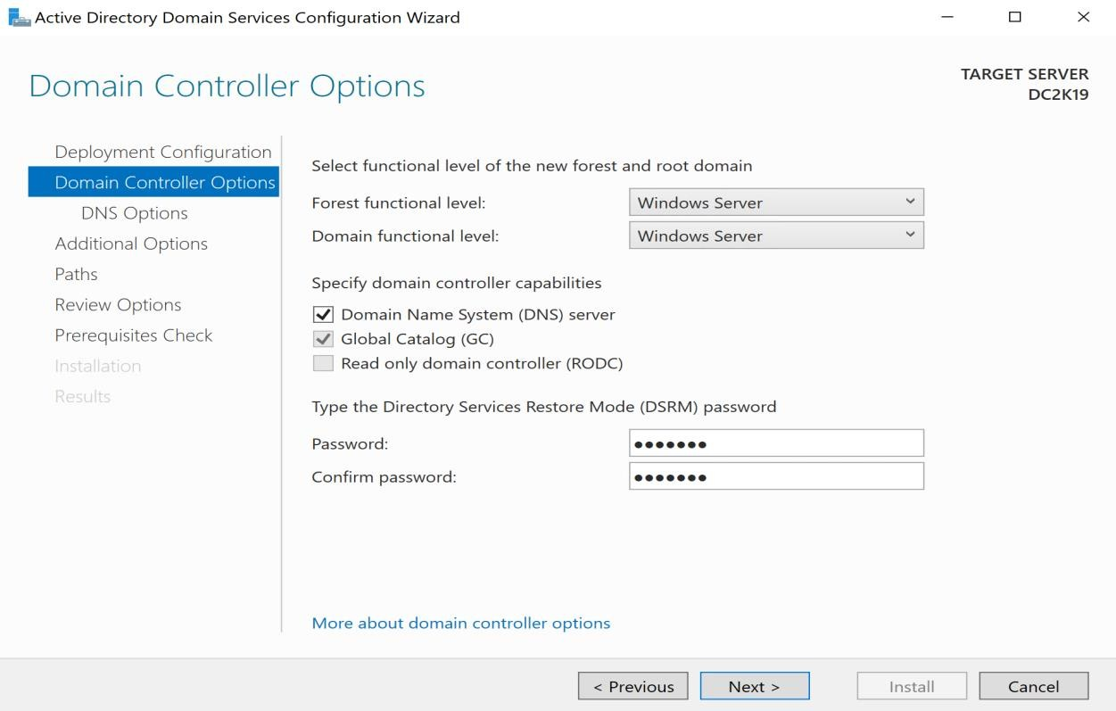

Click Next

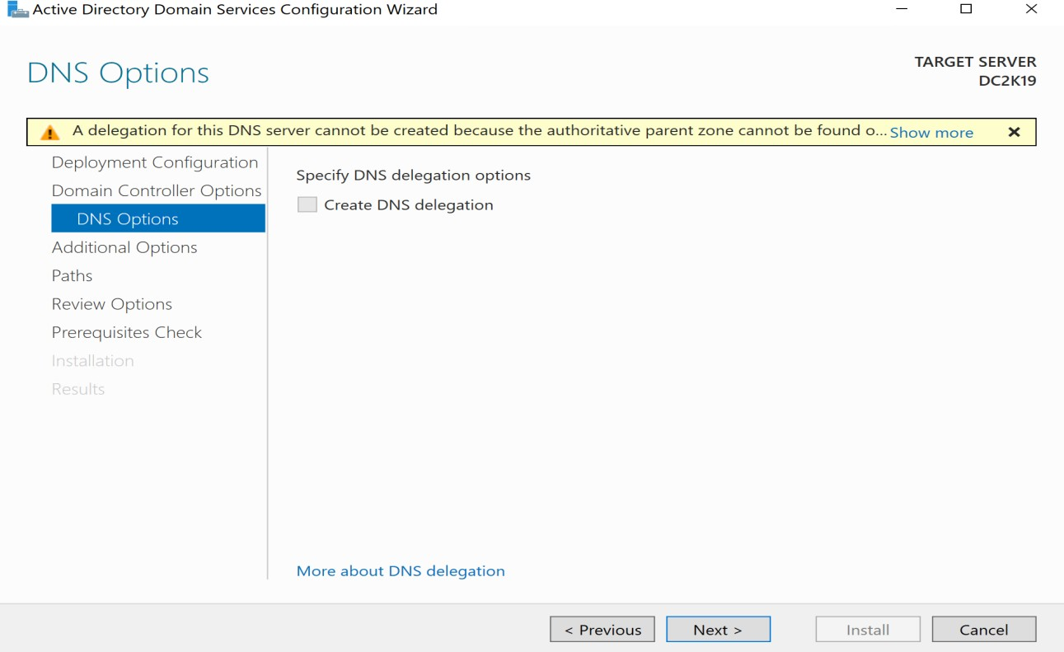

Click Next NetBIOS name will be taken automatically

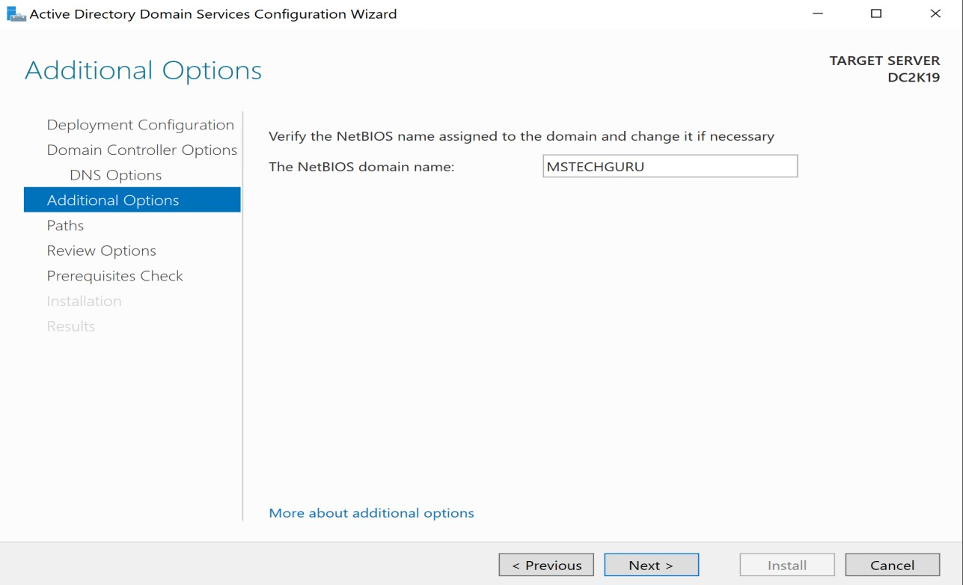

Click next with default options

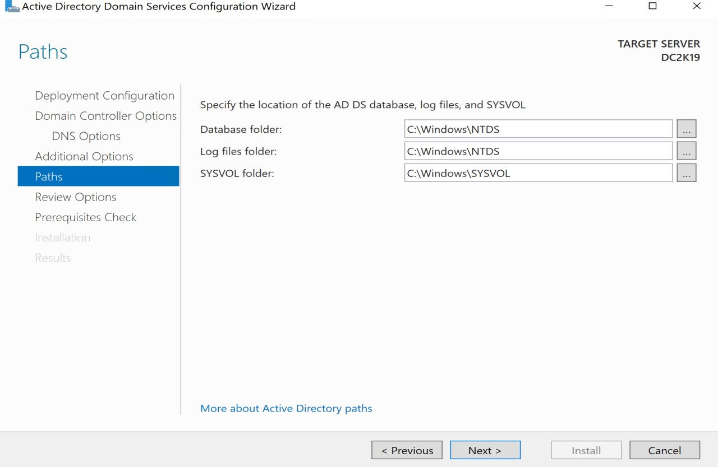

Read the configuration summary and click Next

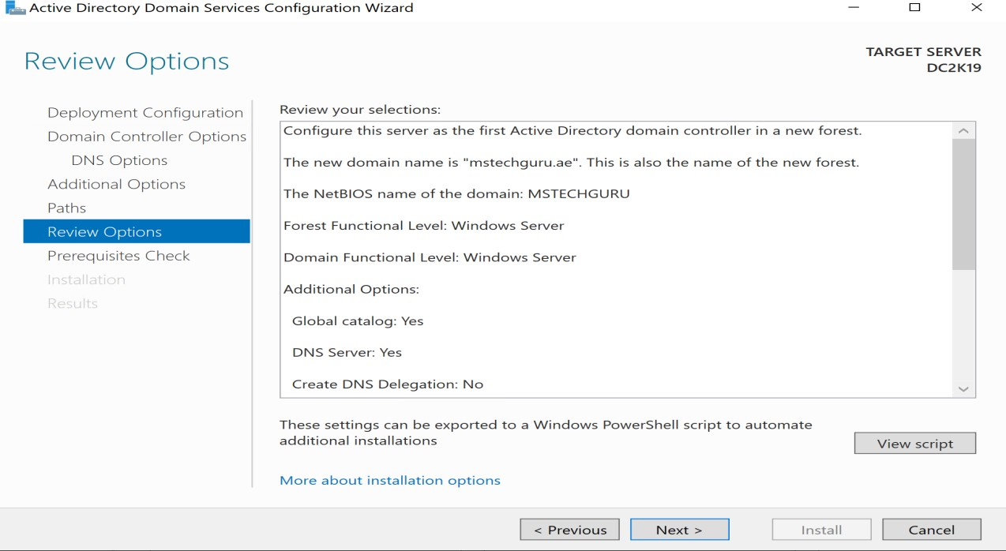

As all prerequisite are passed, Click install

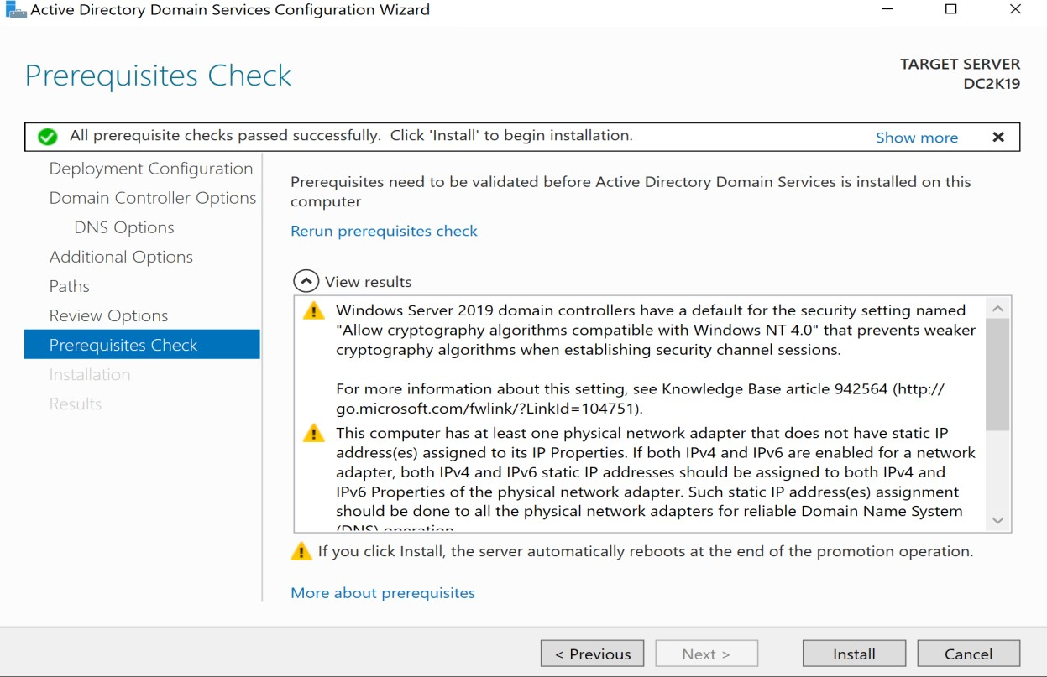

Domain controller installation has completed and it will restart your VM.

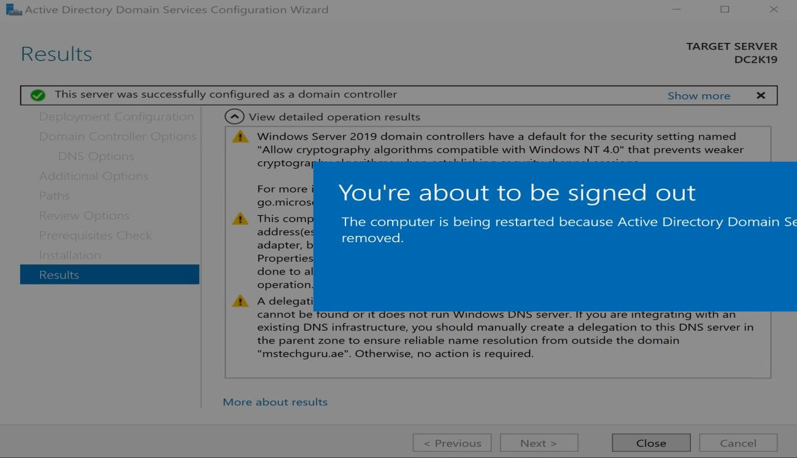

# Exploring Active Directory

As you can see the Active Directory related components are installed and you can explore them one by one. Open Active Directory Users and Computer

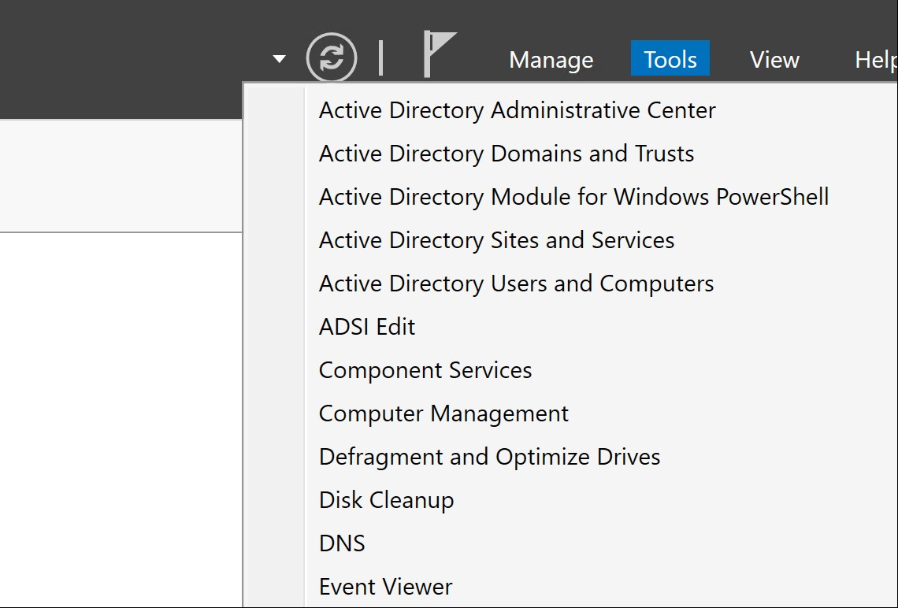

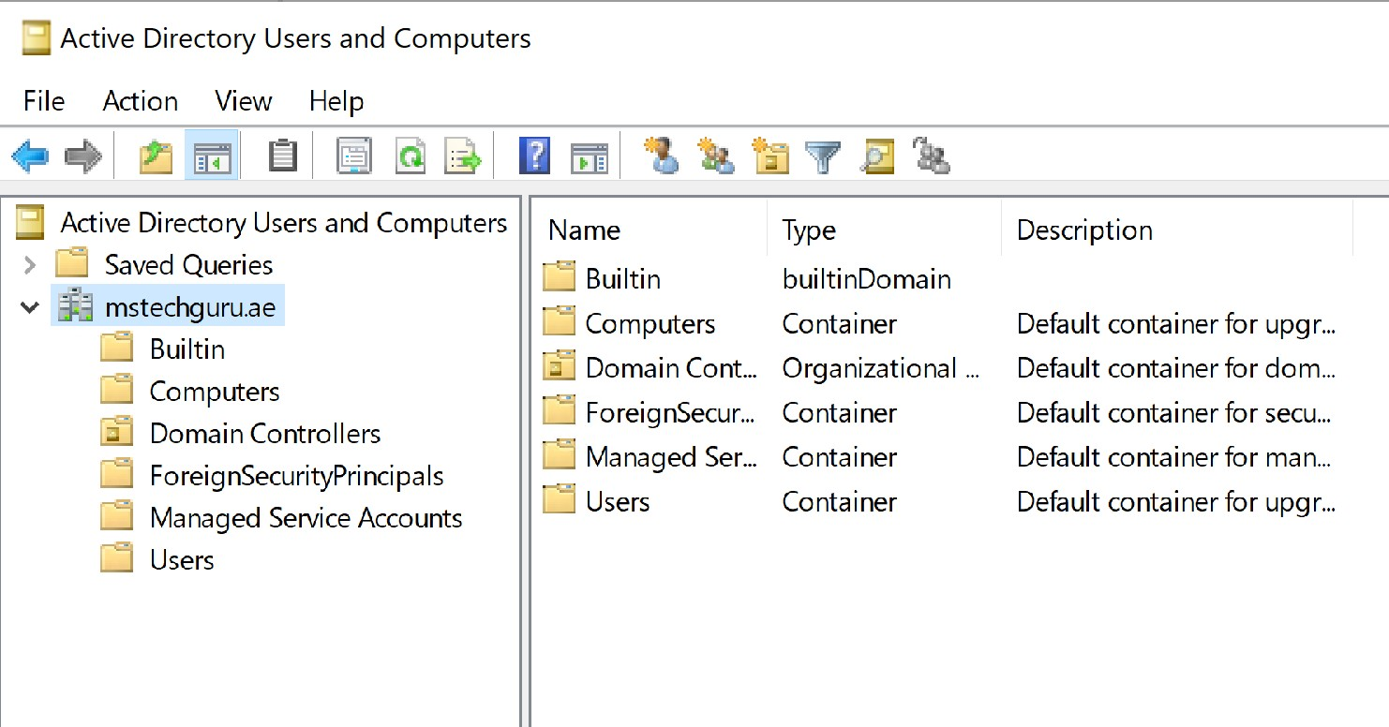.

You can continue further configuration of AD as per your lab requirement such as creation of users and OU etc.

# DNS Configurations

Let’s configure DNS, by default forward lookup will be created during AD installation but we have to create he reverse lookup zone as per our IP address on AD server.

Open DNS from Tools in Server Manager.

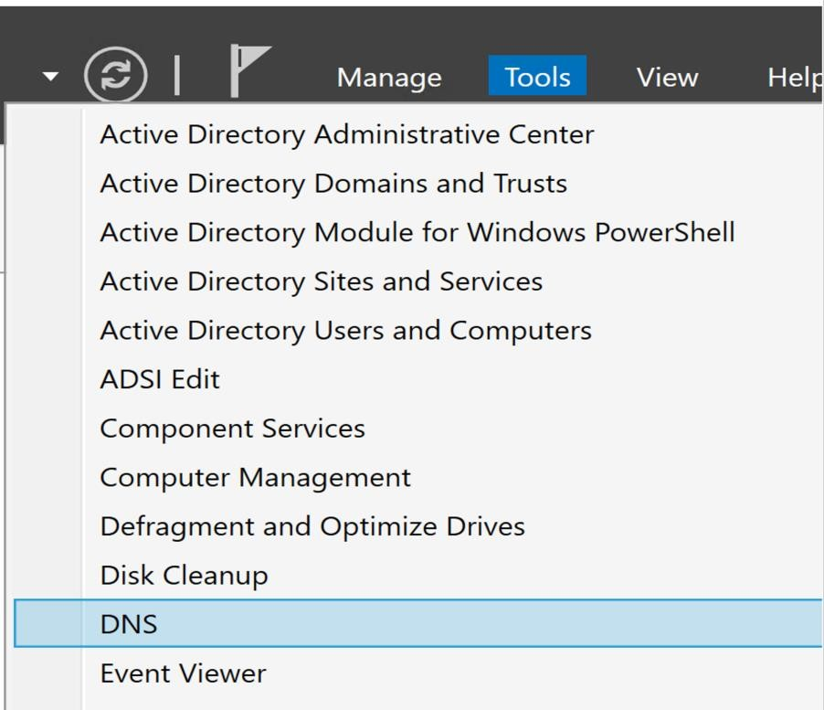

Right click on Reverse lookup zone and Click on New Zone

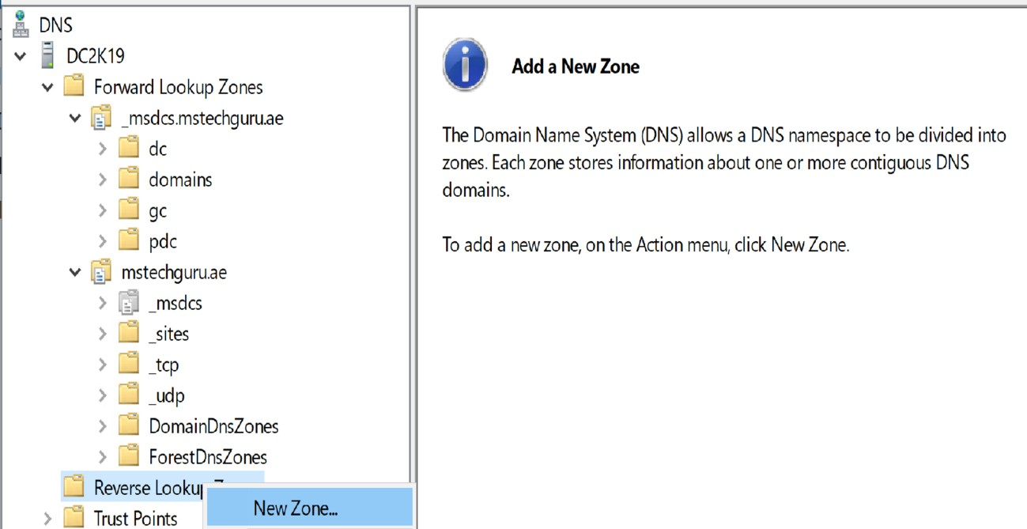

It will give you a wizard.

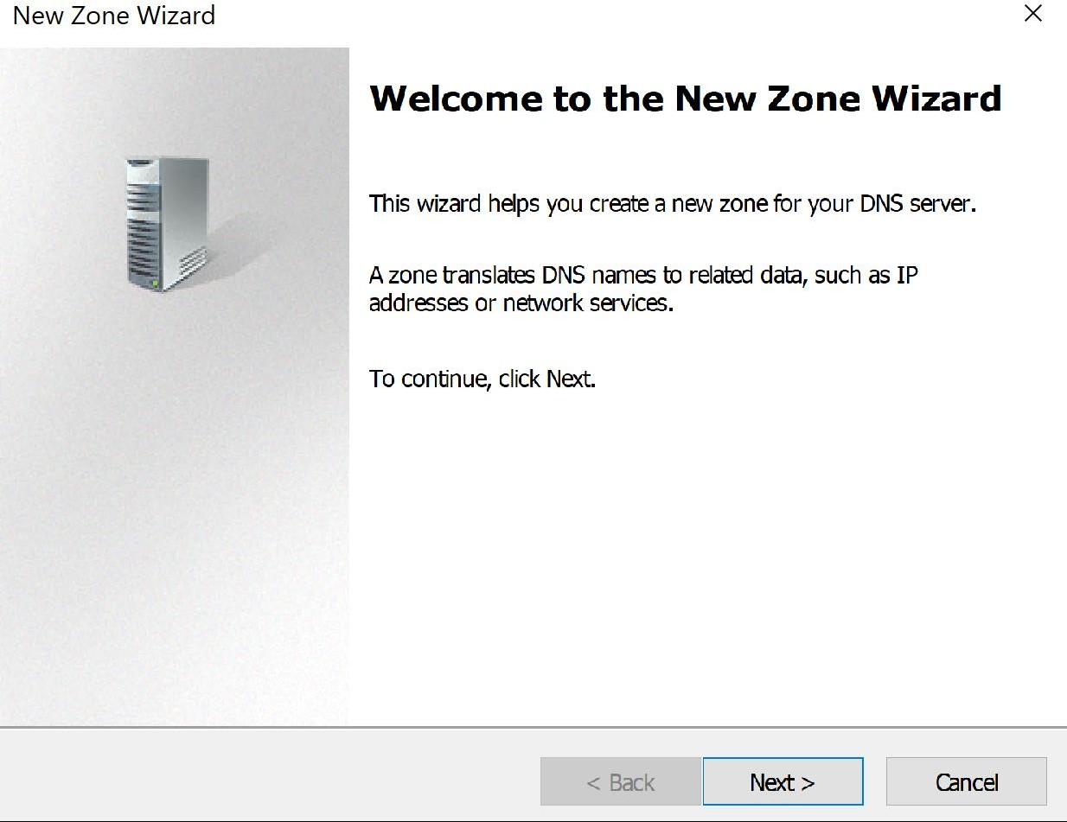

Click Next

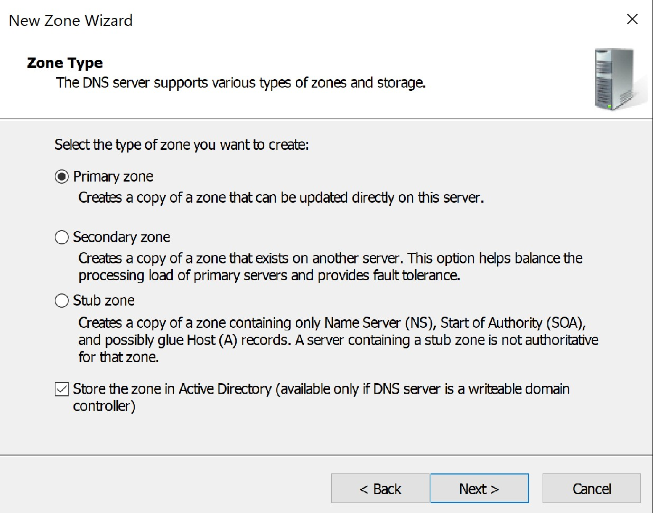

Keep default options and click next

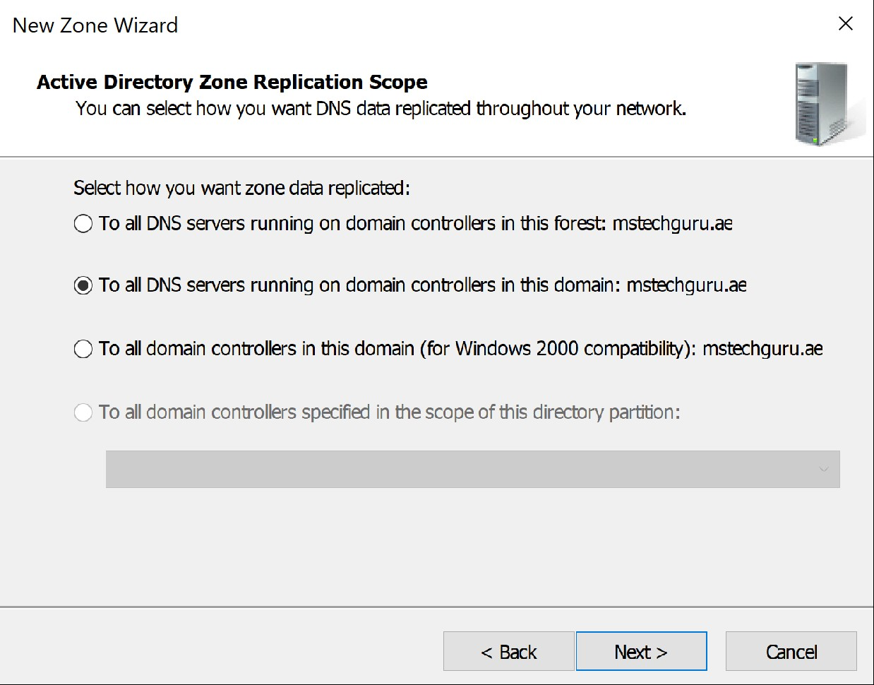

Keep default option selected and click Next.

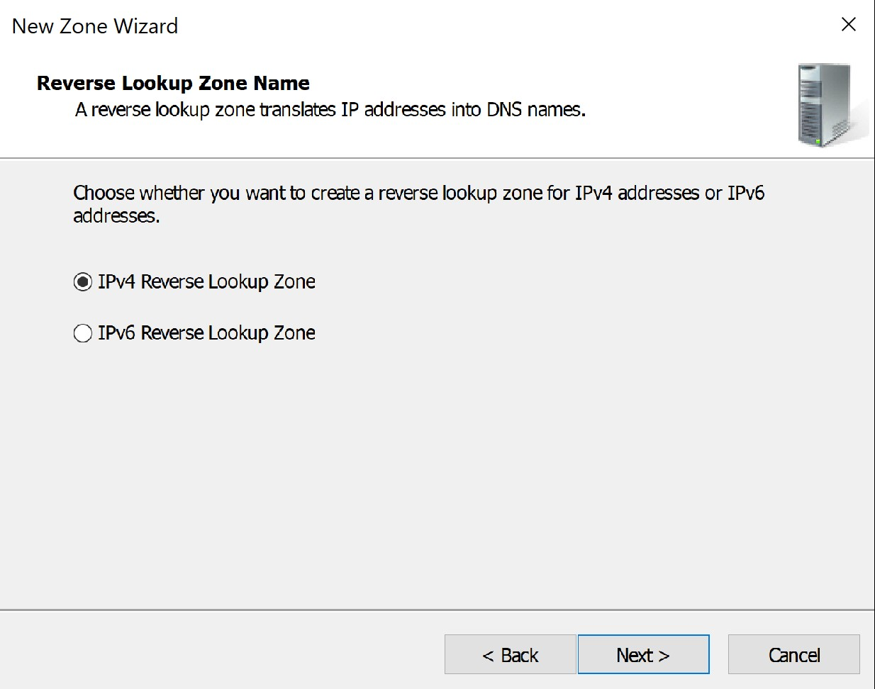

Select IPv4 and click Next

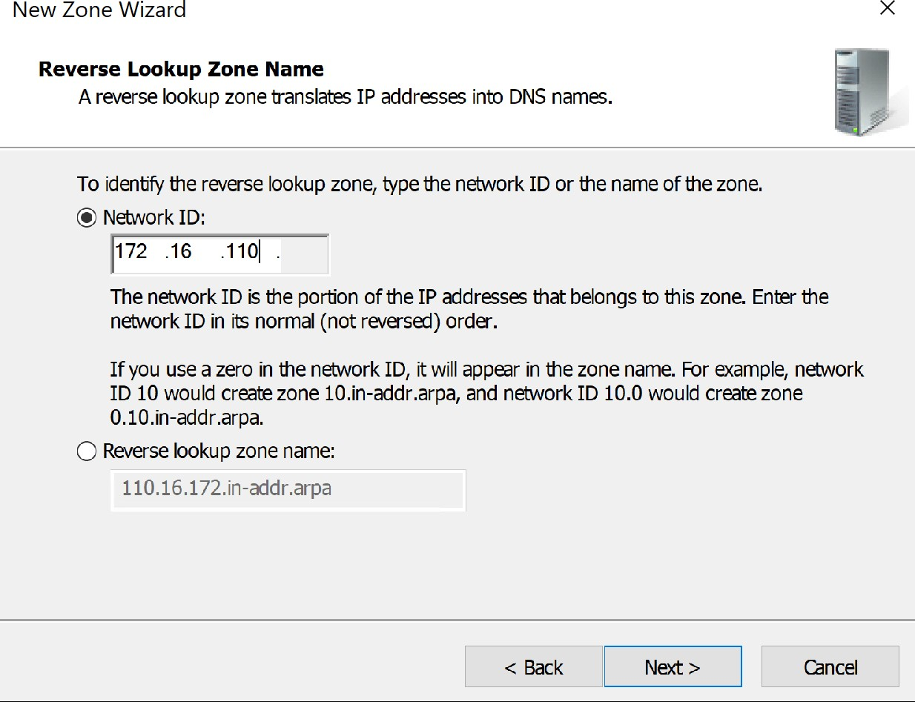

Give your network ID and Click Next

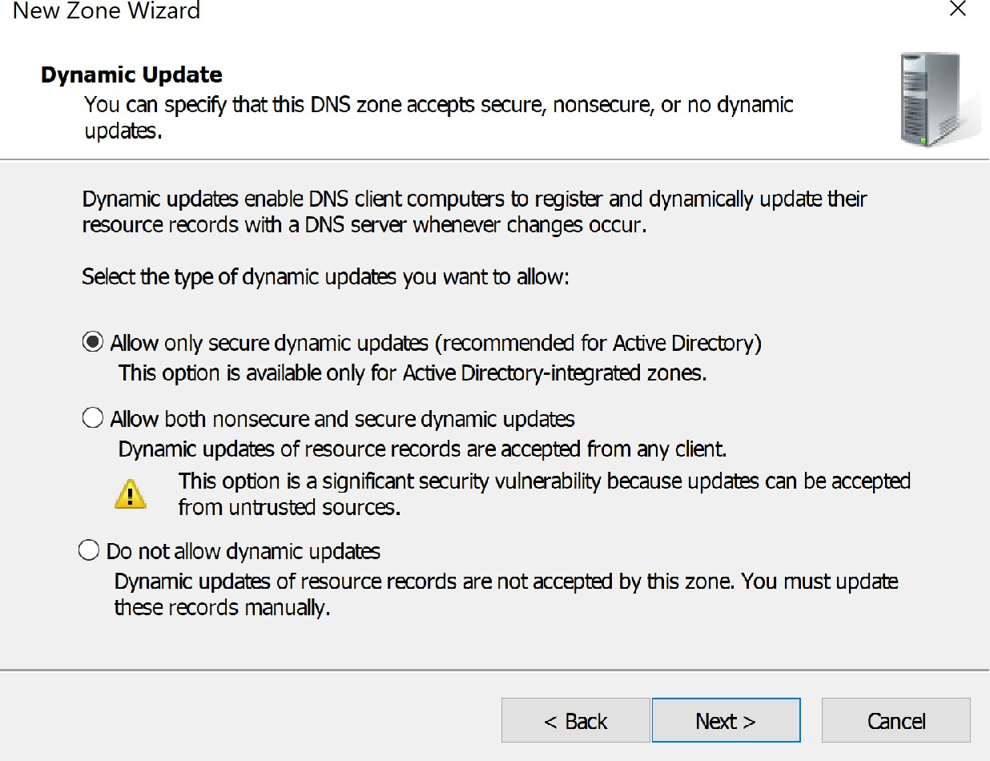

Select first option and click next Select Finish to complete.

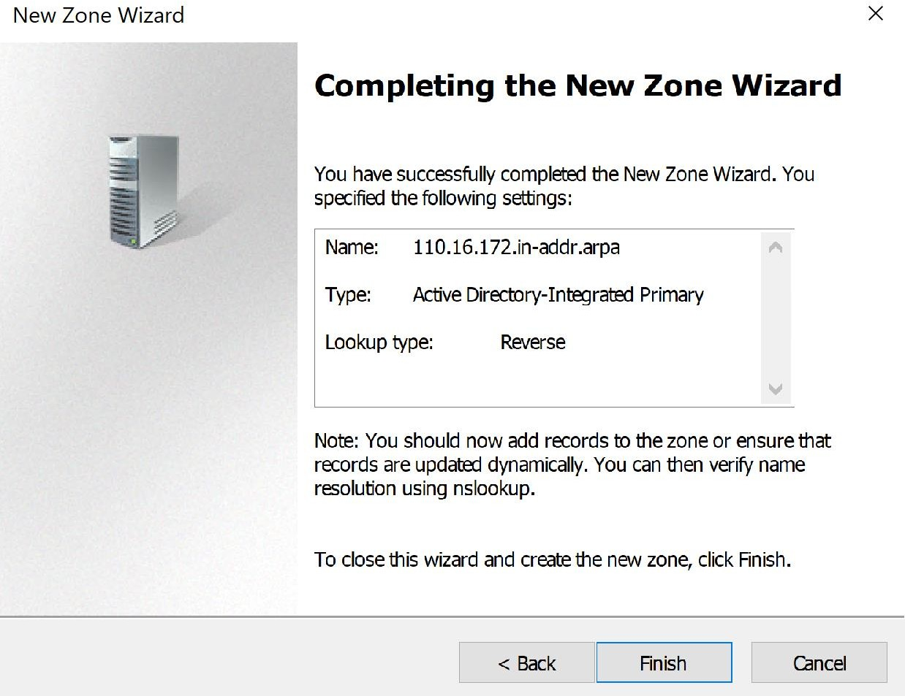

# Reverse Lookup Configuration

Right click on your Network ID and click New Pointer (PTR)

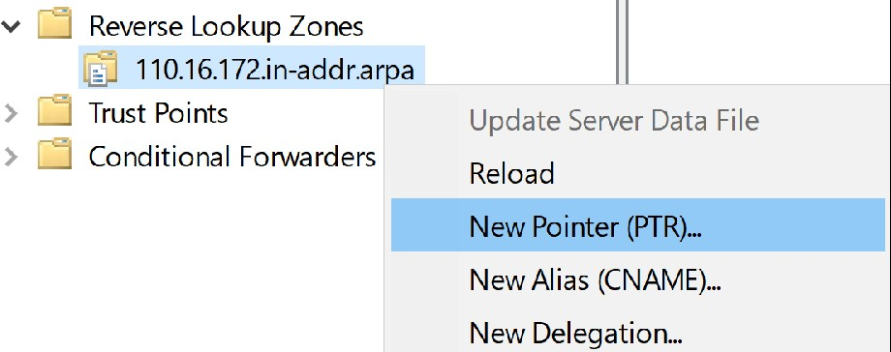

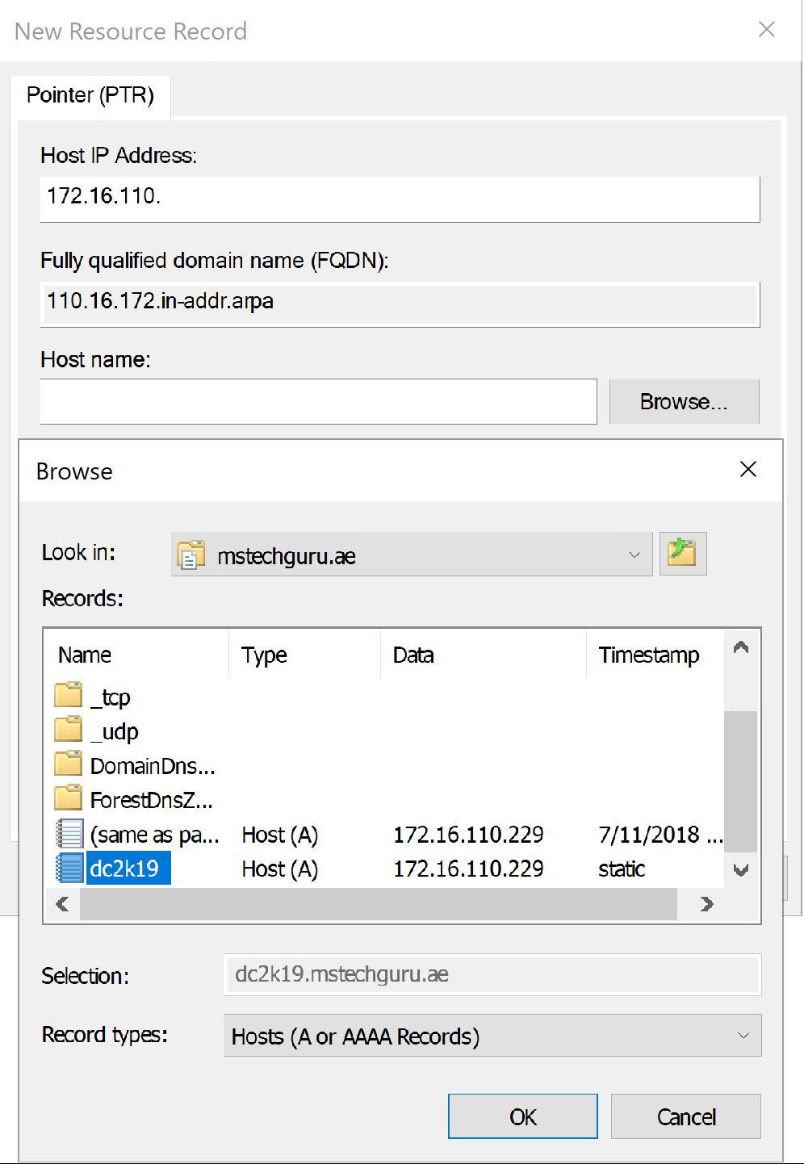

Click Browse and select your DC record and click Ok.

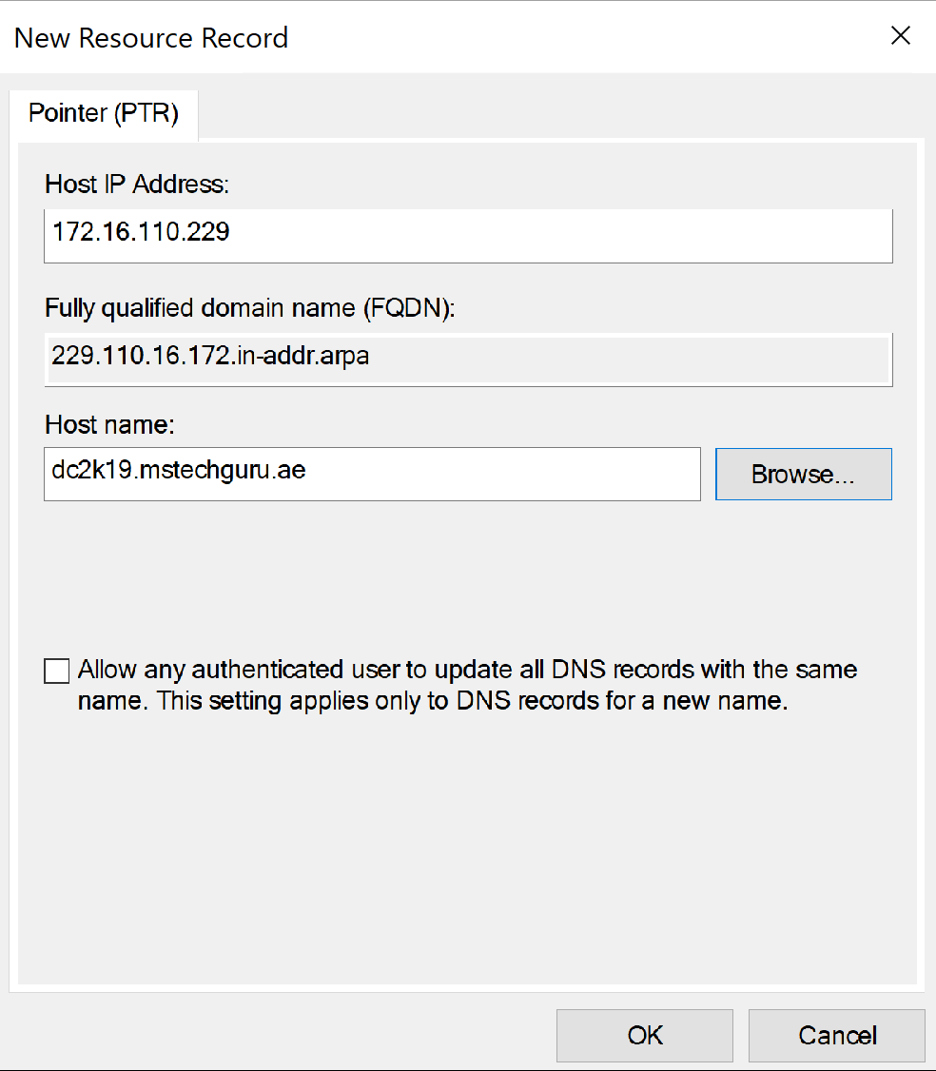

Click OK to finish the setup.

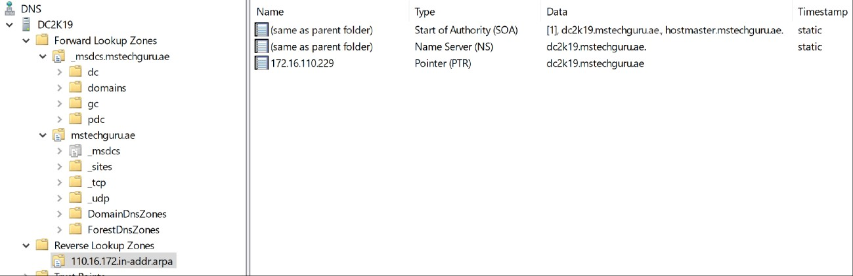

We have completed the DNS configuration at this point and domain controller installation is completed. You can continue using the same setup for further usage and experiments.